Geometry: Unit 7, Lesson H1

- What is the formula to find the sine ratio of a reference angle?

$$\frac{Opposite}{Hypotenuse}$$

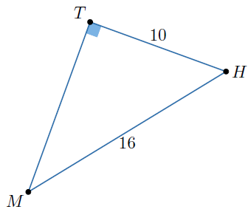

- Right triangle $THM$ is shown where $m∠MTH=90°$, $TH=10$ and $MH=16$. What is the length of $\overline{TM}$, rounded to the nearest hundredth?

$$12.49$$

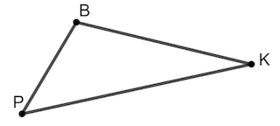
- $∆PBK$ is shown where $\overline{PB}=20$, $\overline{BK}=21$, $\overline{PK}=29$, and $m∠B=90°$. What is an equation that can be used to find the $m∠K$?

$$\sin\left(K\right)=\frac{20}{29}$$

